# SQL Knowledge AND practical skill assessment

**Schema**

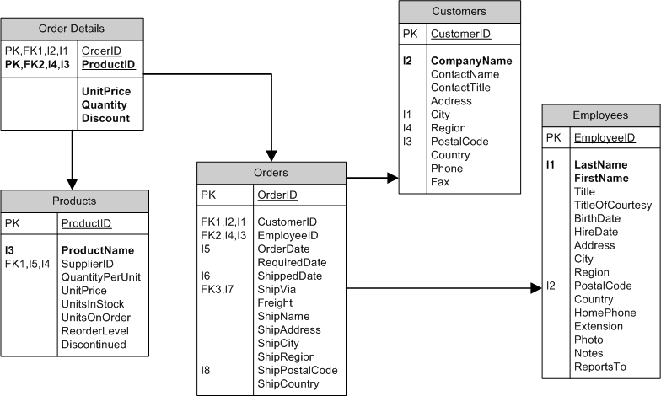

**NOTE: The answers for the below questions do not need to be 100% completed however the answers are expected to be good enough to show us your practical levels of SQL skills and knowledge.**

1. Handwrite an SQL Statement to display employees that live in the city of “Sydney”   
   SELECT *

FROM Employees

WHERE City = “Sydney”;

1. Handwrite an SQL statement to display products and the number of product sold to each customer

Additional Condition: The number of products sold to each customer should be bigger than 1  
SELECT ProductID, SUM(Quantity) AS number_of_products

FROM [Order Details]

WHERE number_of_products > 1

GROUP BY ProductID;

1. Handwrite an SQL Statement to display the customers that have never ordered a product

SELECT *

FROM Customers

WHERE CustomerID NOT IN

(SELECT CustomerID

FROM Orders);